FAIR GROVE POLICE DEPARTMENT

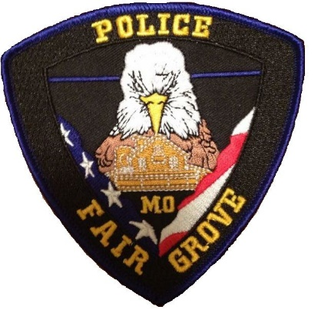

HIRING A FULL TIME PATROL SERGEANT

Have you been in law enforcement for 5 +/- years and are ready to move up? If so, the Fair Grove Police Department may just have a Sergeant position open for you!

As a small department, you will be second in command to the Chief of Police. An associate’s degree or higher is preferred, but can substitute experience for education for the right candidate.

Must be MO POST Certified.

Contact Chief John Ewbank for any questions or inquiries at 417-759-6482 or email police@fairgrove.org

