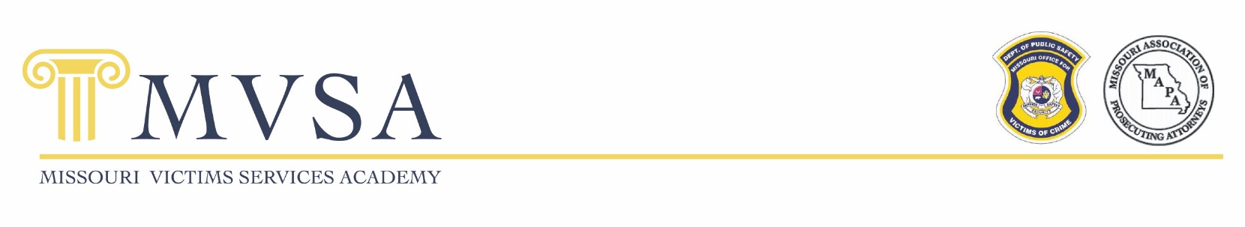
SAVE THE DATE!

2026 Missouri Victim Services Academy
April 22-24, 2026
Jefferson City, MO

The MVSA and the Crime Victims’ Rights ceremony will be held In Jefferson City, Missouri.

MVSA offers learning opportunities for community-based advocates and system-based advocates. Anyone working with victims of crime is welcome to attend! Sessions offered are based on feedback from the field. The agenda includes a variety of material from novice to expert level and an incredible networking opportunity. The DPS-Office for Victims of Crime, the Missouri Association of Prosecuting Attorneys, and the MVSA Planning Committee are committed to delivering an agenda rich in high quality, timely and practical information to increase the capacity of the Missouri victim advocacy network.

A few topics this year include the Intersection of Brain Injury and Domestic Violence, the Juvenile Justice process, Roles of Advocates, and MOVANS 2.0.

Please plan to attend the Crime Victims’ Rights ceremony, at the Missouri State Capitol on Thursday, April 23, 2026.
MARK YOUR CALENDAR
MVSA is April 22-24, 2026, Jefferson City

We are looking forward to another great Academy!
Registration information will be available soon.

FOR MORE INFORMATION CONTACT:

Missouri Department of Public Safety
Office for Victims of Crime
573-751-5954 or CVACP@dps.mo.gov

