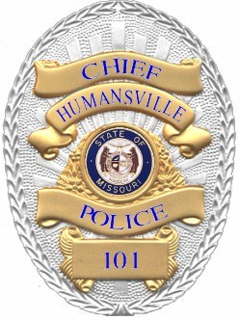

Humansville Police Department
105 E. Lee St.
Humansville, MO 65674
(417) 410-2630

The Humansville Police Department, dedicated to serving our community of 958 residents, is actively recruiting two individuals for reserve police officer positions. Successful candidates will meet the following requirements:

- Minimum age of 21
- High school diploma or equivalent
- Class B or above Missouri POST certification
- Satisfactory driving record and valid Missouri Driver's License
- No pending or prior felony convictions or misdemeanor convictions related to domestic violence
- Background check and drug test will be conducted

As a reserve police officer, responsibilities will include maintaining a commitment of at least 24 hours per month, covering shifts such as days, evenings, overnights, swing, rotating shifts, holidays, weekends, and special circumstances. There are no residency requirements for this position. This reserve position offers an opportunity for potential transition to a full-time role within 6 months, allowing candidates to grow with our department.

To apply, interested individuals should submit a cover letter, resume, and work-related references to the Chief of Police at humansvillepolicedept@gmail.com. Please note that no phone calls are accepted for inquiries.

The Humansville Police Department is proud to be an equal opportunity employer, and we invite you to join our team in ensuring the safety and well-being of our community.

