PEACE OFFICER STANDARDS & TRAINING (POST) COMMISSION
Meeting Minutes

Lewis & Clark State Office Building, 1101 Riverside Drive, Jefferson City

La Charrette and Nightingale Creek Conference Rooms, 1st Floor
Tuesday, April 2, 2024

Opening Welcome
POST Commission Chairperson Chief Mike Wiegand called the meeting to order at 1:00 p.m. with the Pledge of Allegiance and Oath of Honor.

Commissioners Present:
Commission Chairperson Chief Michael Wiegand Eureka PD
Commissioner Sheriff Mark Owen Platte County SO
Commissioner Chief Paul Williams (via WebEx) Springfield PD
Commissioner Sheriff Jim Arnott Greene County SO
Commissioner Chief Gary Hill Lincoln University PD
Commissioner Sheriff David Marshak (via WebEx) Jefferson County SO
Commissioner Director John Worden Law Enforcement Training Institute

Commissioners Not Present:
Commissioner Dr. Emanuel Cleaver III Public Member
Commissioner Major Benjamin Jones Missouri State Highway Patrol
Commissioner Detective Edward Clark St. Louis Metropolitan Police Department

DPS/POST Staff Present:
Sandra Karsten DPS Director
Kevin Bond DPS Deputy Director
Kayla Kemp DPS General Counsel
Austin Davis DPS Deputy General Counsel
Kylie Dickneite Missouri Homeland Security Director
Mike O’Connell DPS Communications Director
Jeremy Spratt POST Program Manager
Cheryl Parris POST Program Senior Specialist
Jessica Rayl POST Program Administrative Support Assistant
Darren Bridges POST Program Investigator
Dale Embry POST Program Investigator
Jeff Collins POST Program Investigator
Troy Thurman MoDEx Information Sharing Coordinator

Visitors:
Sergeant Ron Killingsworth, Director Greene County Sheriff’s Office Law Enforcement Training Academy
Ms. Christina Ayres, Director East Central College – Phelps Law Enforcement Training Center
Ms. Laura Wright Missouri State University Public Safety Training Center
Chief Cheryl Funkhouser Chesterfield Police Department
Mr. Les Kerr U.S. Attorney’s Office – Western District of Missouri

Approval of October 5, 2023 Meeting Minutes
Chairperson Wiegand asked for a motion to approve the meeting minutes as written. Commissioner Arnott made a motion to approve the minutes as written, which was seconded by Commissioner Owen. The motion passed unanimously.

Approval of December 12, 2023 Special Meeting Minutes
Chairperson Wiegand asked for a motion to approve the meeting minutes as written. Commissioner Owen made a motion to approve the minutes as written, which was seconded by Commissioner Worden. The motion passed unanimously.

MoDEx Update
The MoDEx process, Information Sharing Coordinator Troy Thurman presented handouts to the POST Commission about the FY 24 financial data review and the FY 25 budget request.

Slides 1 and 2 contained introductory information of Mr. Thurman’s presentation.

Slide 3 covered the FY 24 MoDEx monthly fund balance as of April 1, 2024, which is $1,507,684.21. The fund is averaging $39,332.45 per month in deposits. There is an estimated $117,997.37 in total deposits remaining for April, May, and June. Mr. Thurman made note that the MoDEx fund is still 26% down from 2016, but 3% higher than last year.

Slide 4 covered the FY 24 MoDEx expenditures, deposits, and interest for each month. Mr. Thurman highlighted the two spikes in expenditures were computer vendor maintenance payments to continue the data flow from existing agencies. Mr. Thurman explained that MoDEx is in the process of its 7th project, which is the 6th expansion and enhancement project. He explained the current project is a Computer Aided Dispatch (CAD) to CAD project to link CAD systems during a mutual aid event and to share data to N-DEx for searching later.

Slide 5 covered the FY 24 funding expenditure disbursement and percentage of funding spent. Mr. Thurman explained that the yellow expansion area is currently at $0.00 expenditures, but there is an outstanding $160,000.00 bill due before the end of the fiscal year to finish the CAD-to-CAD process. Director Karsten asked Mr. Thurman to expand upon the CAD-to-CAD process and explain what it will actually do. Mr. Thurman explained the CAD-to-CAD process more in depth pointing out the current process communications operators utilize during a mutual aid event. While the current process is utilizing telephone calling and relaying of information, the new process will link the CAD systems and share information in near real time. The CAD-to-CAD process will also allow for additional agencies to be added, and once added to a mutual aid event, they will get all the previous call for service notes. The process should speed up mutual aid assistance, provide for more accurate information being shared about an incident, as well as improve officer safety by providing the responding officers more factually available information. Commissioner Owen asked if this interface would work regardless of the vendor’s CAD system. Mr. Thurman said, “yes,” it is being designed on a two-pronged process to operate with National Emergency Number Association (NENA) EIDO standards, as well as the latest National Law Enforcement Telecommunications System (NLETS) standards, and the CAD-to-CAD process will translate data between the two standards commonly utilized in vendor CAD systems nationally. Mr. Thurman explained that the 911 Service Board is represented in the CAD-to-CAD build and are serving as advisors to ensure things are being built to the latest standard and to meet the needs of Missouri. Mr. Thurman explained that once the project is completed, Missouri will own the process so there will not be any reoccurring maintenance cost, other than for additional development to expand and/or enhance the capabilities.

Slide 6 was transitional to the FY 25 MoDEx Budget Request.

Slide 7 covered FY 25 Budget Request overview. Mr. Thurman briefly explained the FY 25 Budget Request and that more in-depth information would be covered in the next slides.

Slide 8 covered Management & Administration (M&A) funding estimates for the budget request. Mr. Thurman explained that with all the advancements and improvements with MoDEx, the Information Technology (IT) needs for MoDEx has exceeded what the Missouri State Highway Patrol IT staff can support as additional taskings on top of their regular duties. MoDEx needed a dedicated IT staff person to focus on supporting the IT needs of MoDEx. One MoDEx IT staff position was being added and will be funded from a mix of MoDEx funds, DPS GR Funds, and Missouri Office of Homeland Security funds. Mr. Thurman went on to explain that the M&A funds also include the equipment and supplies, travel, and training in FY 25.

Slide 9 covered the current vendor maintenance cost. The $124,098.97 requested will sustain the MoDEx process vendor cost exactly as it is currently, without any improvements and/or additions with the vendors listed.

Slide 10 is the FY 25 Budget Request. Mr. Thurman explained the slide. The current fund balance of $1,507,684.21 was at the top, followed by the $350,000 explained as providing a reserve contingency previously approved by the POST Commission and could sustain current M&A, and vendor maintenance cost for 1 year if the MoDEx fund experiences reduced funding deposits. The FY 25 budget requested was at the bottom of the slide and totaled $1,157,684.21.

Slide 11 was the conclusion of the presentation, allowing time for any questions.

Commissioner Wiegand asked if there were any questions from the Commission. Commissioner Marshak asked if there was a way to help support MoDEx and get the cost down with the differences in the vendor maintenance cost. Mr. Thurman explained that the varied cost was due to several factors. Each vendor has its own maintenance cost contracted with the State of Missouri, but also that each vendor has a varied number of agencies, and that the contracted cost along with the number of agencies is what creates the wide difference in the maintenance cost. Mr. Thurman explained that there really isn’t anything that can be done, and the numbers are driven by the local agency’s choice in system vendors, and the total numbers of how many of those agencies want to share their data. Sheriff Arnott asked if all vendors charged a fee. Mr. Thurman explained that not all vendors charge a fee, but some do.

Commissioner Owen stated he wanted to thank Mr. Thurman since he has been part of the MoDEx Advisory Board where they struggled with paying vendors lots of money for very little results that were over inflated, and that, fiducially, Mr. Thurman has done an excellent job taking MoDEx forward.

Commissioner Wiegand asked if there were any other questions, and there were none. Commissioner Owen stated he would make a motion to pass the MoDEx budget. Commissioner Hill seconded the motion to accept the FY 25 proposed budget of $1,157,684.21 for MoDEx. Commissioner Wiegand asked if there was any further discussion, and there was none. The motion was put to the Commission for a vote and the motion passed unanimously.

Attached Presentation Slides 1 through 11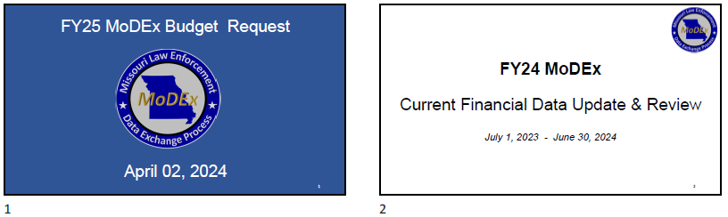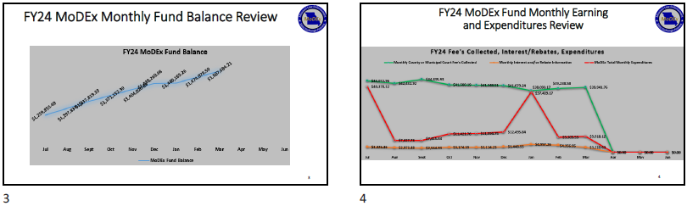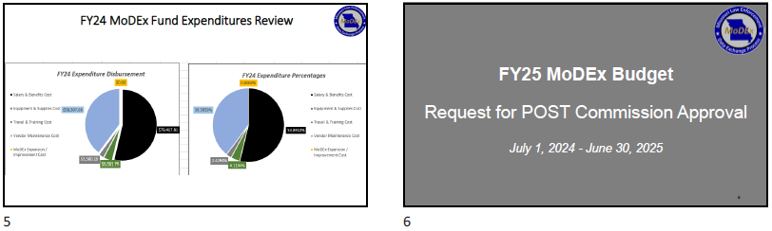

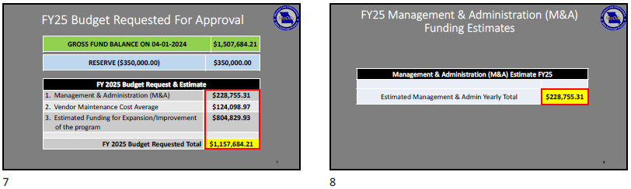
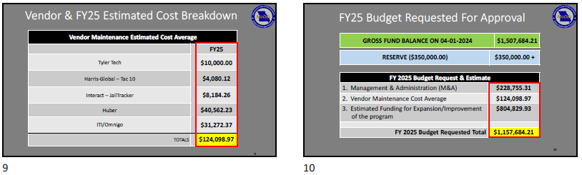

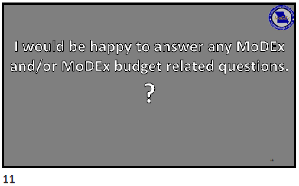

Disciplinary Report

Mr. Spratt reported that the following actions were taken by the Director of Public Safety and the POST Program from September 27, 2023, through March 26, 2024.

Peace Officers:

Cases initiated: 126

Licenses revoked: 12

Licenses probated: 8

Licenses suspended: 5

Voluntary surrender (permanent): 9

Letters of Reprimand: 10

No action after investigation: 44

Officers under immediate suspension (pending hearing): 32

Backlogged Cases/Pending Director’s Decision: 0

Basic Training/License Applicants:

Applicant questionnaires reviewed and approved for entry: 254

Applicants pending: 6

Applicants denied entry: 4

Applicants allowed entry after investigation/hearing: 8

Denied application for license: 1

Current Caseload:

Active cases at POST: 143

Active cases at the AG’s office: 190

Total caseload: 333

Updated Basic Training Learning Objectives and Source Documents
Since the October 5, 2023 POST Commission meeting, Mr. Spratt stated the subject-matter experts for three blocks of the basic training curriculum updated their respective topics of responsibility. As per the approved process, the 21 licensed basic training center directors agreed with the proposed revisions, which will be effective on the dates noted below:

- 1201 – Introduction to Report Writing (Effective 8/29/2024)
- 1203 – Report Writing Exercises (Effective 8/29/2024)
- 300 – Missouri Statutory Law (Effective 9/01/2024)

Mr. Spratt stated the subject matter expert for 1104 – Crime Scene Investigation is nearly finished with an extensive update to this 46-hour block of instruction, which he hopes to have finalized and sent to the 21 licensed basic training center directors for review and comment prior to the October 2024 POST Commission meeting.

Training Center Audits
Mr. Spratt stated POST Program representatives completed programmatic audits of the following eleven licensed training providers since the October 5, 2023 POST Commission meeting:

- Eastern Missouri Police Academy
- Jefferson College Law Enforcement Academy
- MCC Blue River – Public Safety Institute
- Missouri Western State University Regional Law Enforcement Academy
- Southeast Missouri State University Law Enforcement Training Academy
- St. Louis County and Municipal Police Academy
- St. Louis Police Academy
- East Central College – Phelps Law Enforcement Training Center
- Missouri State University Public Safety Training Center (CLEE only)
- Missouri Division of Fire Safety (CLEE only)
- Missouri Police Chiefs’ Charitable Foundation (CLEE only)

Based upon the results of the programmatic audits, Director Karsten renewed the licenses of the eleven training providers for a period of three years.

Public Comments
There were no public comments.

October 2024 Meeting Date
The next regular POST Commission meeting is scheduled for Tuesday, October 15, 2024, at 1:00 p.m. in the Lewis and Clark Building, Jefferson City, Missouri. The mandatory basic training center directors’ meeting will be held on the same day, starting at 10:00 a.m.

Adjourn Meeting
Seeing no additional topics on the agenda for discussion, Chairperson Wiegand ask for a motion to adjourn the meeting. A motion was made by Commissioner Worden and seconded by Commissioner Hill. There was no opposition, and the POST Commission adjourned the meeting at 1:37 p.m.

